**실습1**

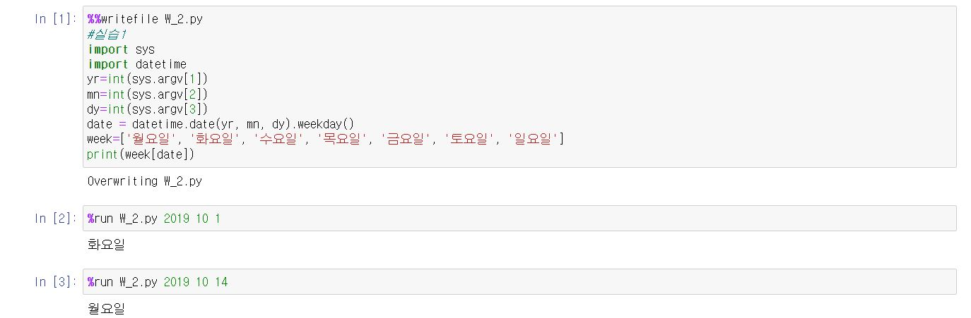

**실습2-1**

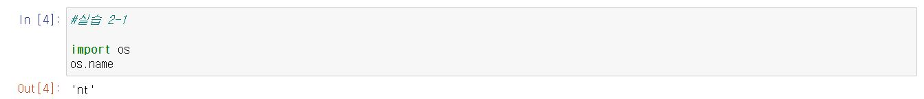

**실습2-2**

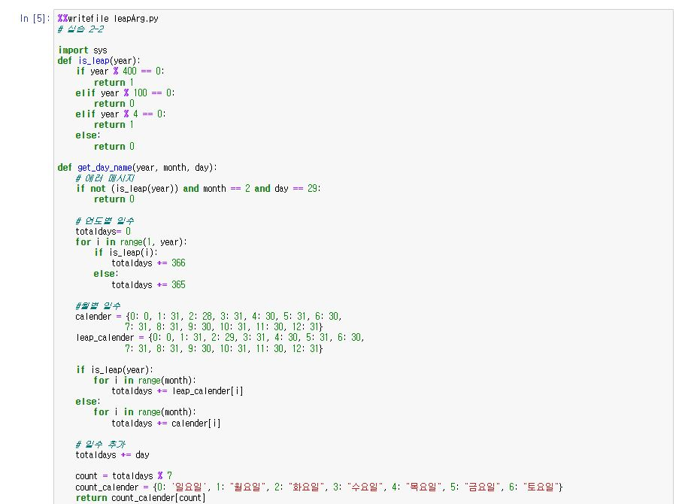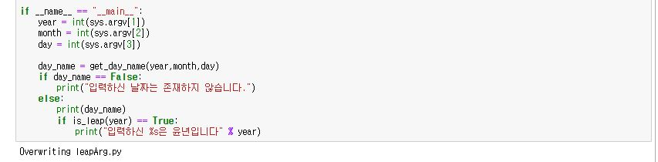

**실습2-3**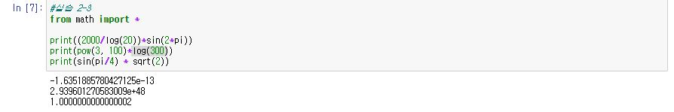

**실습2-4**